**BA with R Session3 Assignment1**

1. Numerical Vector to store the odd numbers between 1:100

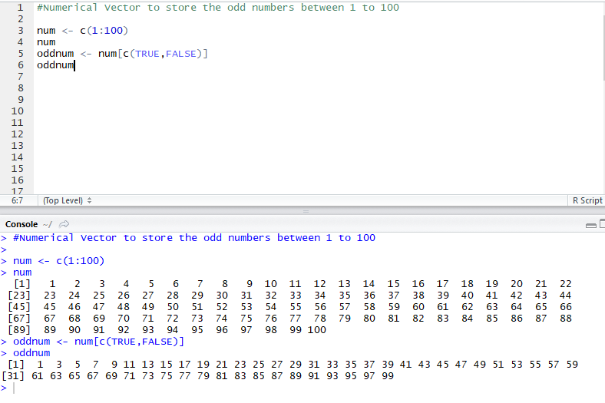

2. Matrix creation for a given vector

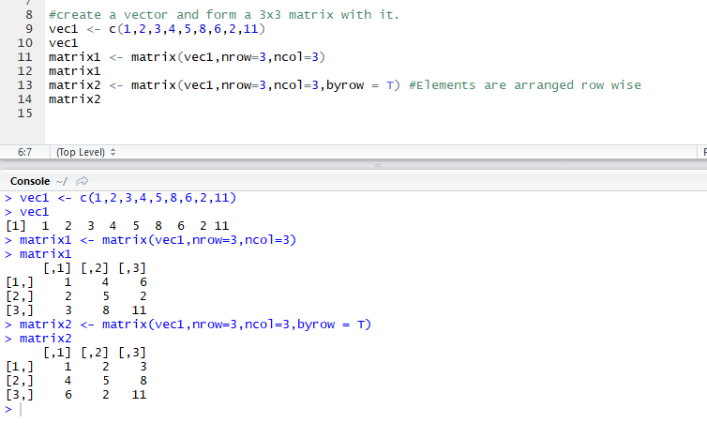

3. Removing NAs and finding the mean of the vector.

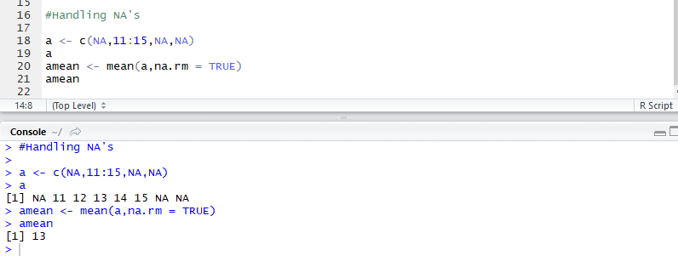

4. Replacing the first occurrence of a pattern with another

